Fractions  
--------------

1. Write the fraction representing the shaded portion.

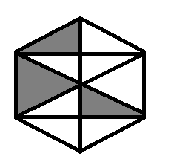

1. Shade 3/8 of the given picture.

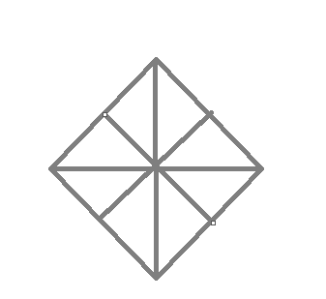

1. What fraction of a July month is 17th day?
2. How many prime numbers are there from 1 to 15? Calculate the fraction of them.
3. Which of the following are proper fractions?

$\frac{1}{2}$, $\frac{4}{5}$, $\frac{10}{10}$, $\frac{13}{15}$, 4 , $\frac{22}{15}$

1. Write 6 improper fractions with numerator 7.
2. Convert each of the following into the mixed fraction:

$\frac{19}{7}$

$\frac{71}{3}$

$\frac{95}{17}$

$\frac{112}{21}$

1. Write five fractions equivalent to each of the following:
$\frac{3}{2}$

$\frac{5}{7}$

$\frac{8}{4}$

$\frac{6}{12}$

2. Find the equivalent fraction of 28/36 with numerator 7 and denominator 4.
3. Show that each of the following fractions is in the simplest form:

$\frac{7}{10}$, $\frac{9}{17}$, $\frac{25}{36}$

1. Convert following into like fractions.

$\frac{4}{7}$, $\frac{6}{9}$, $\frac{14}{28}$

1. Find the sum of following:

$\frac{7}{3}+\frac{2}{8}$, $\frac{7}{11}+\frac{8}{15}$, $2+\frac{3}{5}+1\frac{5}{8}$ + 3 $\frac{7}{10}$

1. Sham bought a pen for 4 $\frac{5}{9}$ and notebook for 7 $\frac{6}{7}$. What is the total cost of both the articles.
2. The weight of an empty bucket is 1 $\frac{2}{2} KG$ and it contains 3 $\frac{4}{6}$ KG of water. What is the weight of the bucket filled with water?
3. A fraction equivalent to 4/7 is

4+7 4-7 4x2  
------ , ------ , ------ , None of these.  
3+3 7-4 7x2

1. If 27/30 is equivalent to 3/x the value of x is
2. 4
3. 5
4. 6
5. 10
6. None of the above.